Topology Qualification Exam, Spring 2020

Instructions
Please attempt 8 out of 9 problems and clearly mark the one you do not want us to grade.

Problems
- Let $f:X→Y$ be a surjective, continuous map of topological spaces.
  - Show: if $f$ is an open map, then it is a quotient map.
  - Show: if $f$ is a closed map, then it is a quotient map.
- Show that a connected metrizable space with at least two points is uncountably infinite. (You may use without proof that every metrizable space is normal.)
- Let $(X,d_{X})$ and $(Y,d_{Y})$ be metric spaces. An isometric embedding $ι:X→Y$ is a map such that
$$∀x_{1},x_{2}∈X, d_{Y}\left(ι(x_{1}),ι(x_{2})\right)=d_{X}(x_{1},x_{2}).$$
- An isometry is a surjective isometric embedding.
  - Show that every isometric embedding from a compact metric space to itself is an isometry. (You may use that a metric space is compact iff it is sequentially compact.)
  - Show that every isometric embedding from Euclidean $n$-space to itself is an isometry.
- Consider the solid $S$ obtained by digging out the center of a 3-dimensional solid ball and 4 tunnels from the center to the boundary. What is the genus of the boundary surface $Σ=∂S$? Justify your answer.
- 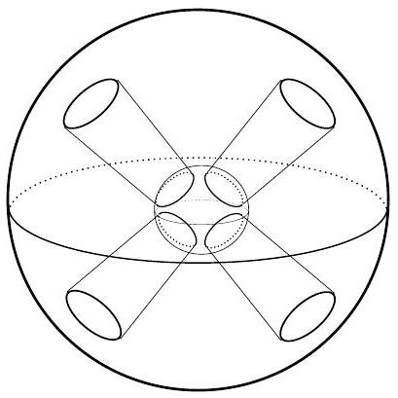
- Figure for Problem 4.
- Let $X$ be the topological space obtained by attaching a disk to $T^{2}=S^{1}×S^{1}$ along the circle $S^{1}×\{p\}$ via the map $z↦z^{5}$. Compute the fundamental group and the homology groups of $X$.
- Classify the connected 2-fold covering spaces of the Klein bottle $K$. (You might want to consider $K$ as the union of two Möbius bands.)
- Show that every continuous map from $RP^{2}×RP^{2}$ to $T^{4}=S^{1}×S^{1}×S^{1}×S^{1}$ is nullhomotopic.
- Let $X=RP^{5}/RP^{1}$, and let $f:X→X$ be a continuous map that is homotopic to the identity. Show that $f$ must have a fixed point.
- Describe the CW structure of $X=CP^{2}×RP^{2}$ and use it to compute the homology groups of $X$.

